**Introduction to Computer Programming Student Setup Instructions**

**Joining Zoom, as a new member**

1. Click the following or paste the following address in to your browser address:

<http://zoom.us>

The following window should appear:



Mouse-click the (SIGN UP, IT’S FREE) button in the upper right.

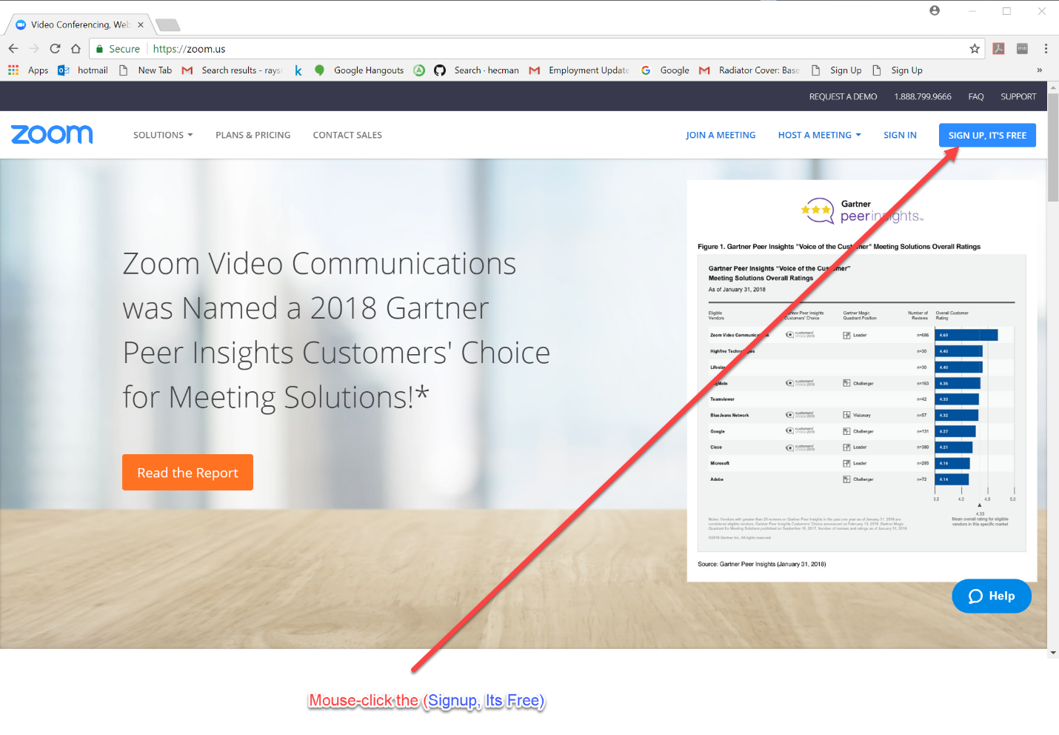

The following window should appear:

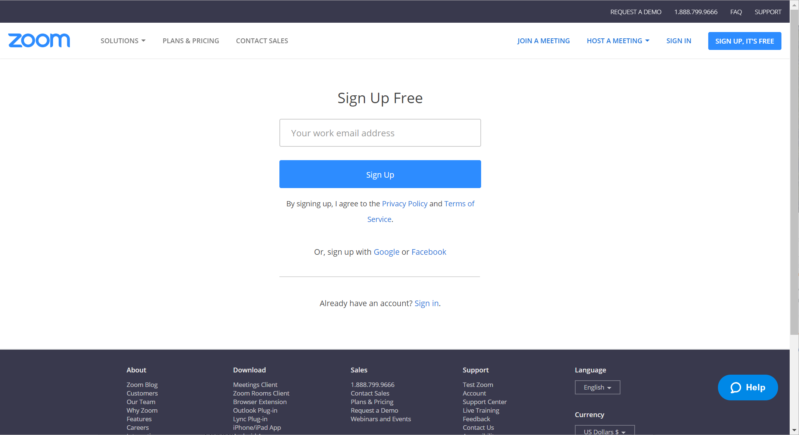

**Joining the Class Meeting in Session**

1. Click the following or paste the following address in to your browser address:

<https://zoom.us/j/2821636776>

If you are new to Zoom:

After download completes, click Zoom_Launcher.exe in lower left corner of screen.

If you see “Do you want to run this file? …Zoom_Launcher…” click the “Run” button.

To the prompt: “Please Enter Your Name”, enter your name, then click **Join.**

If you are in the same room as the speaker, please mute your microphone by clicking the microphone icon in the lower left corner of the Zoom window.

**Using PythonAnywhere**

PythonAnywhere is an online resource which can easily provide quick access to Python. We will be using it extensively for this course. The following steps provide you access.

**Connecting to PythonAnywhere**

Via Web Link

Select the following link (CTL Mouse Right-Click) or paste Web link text in to browser address field.

Web link: <https://www.pythonanywhere.com/>

Via Web Searching

Type or paste “pythonanywhere” into your browser’s search field.

Click on “PythonAnywhere – Official Site”

The PythonAnywhere home site should appear as the figure below.

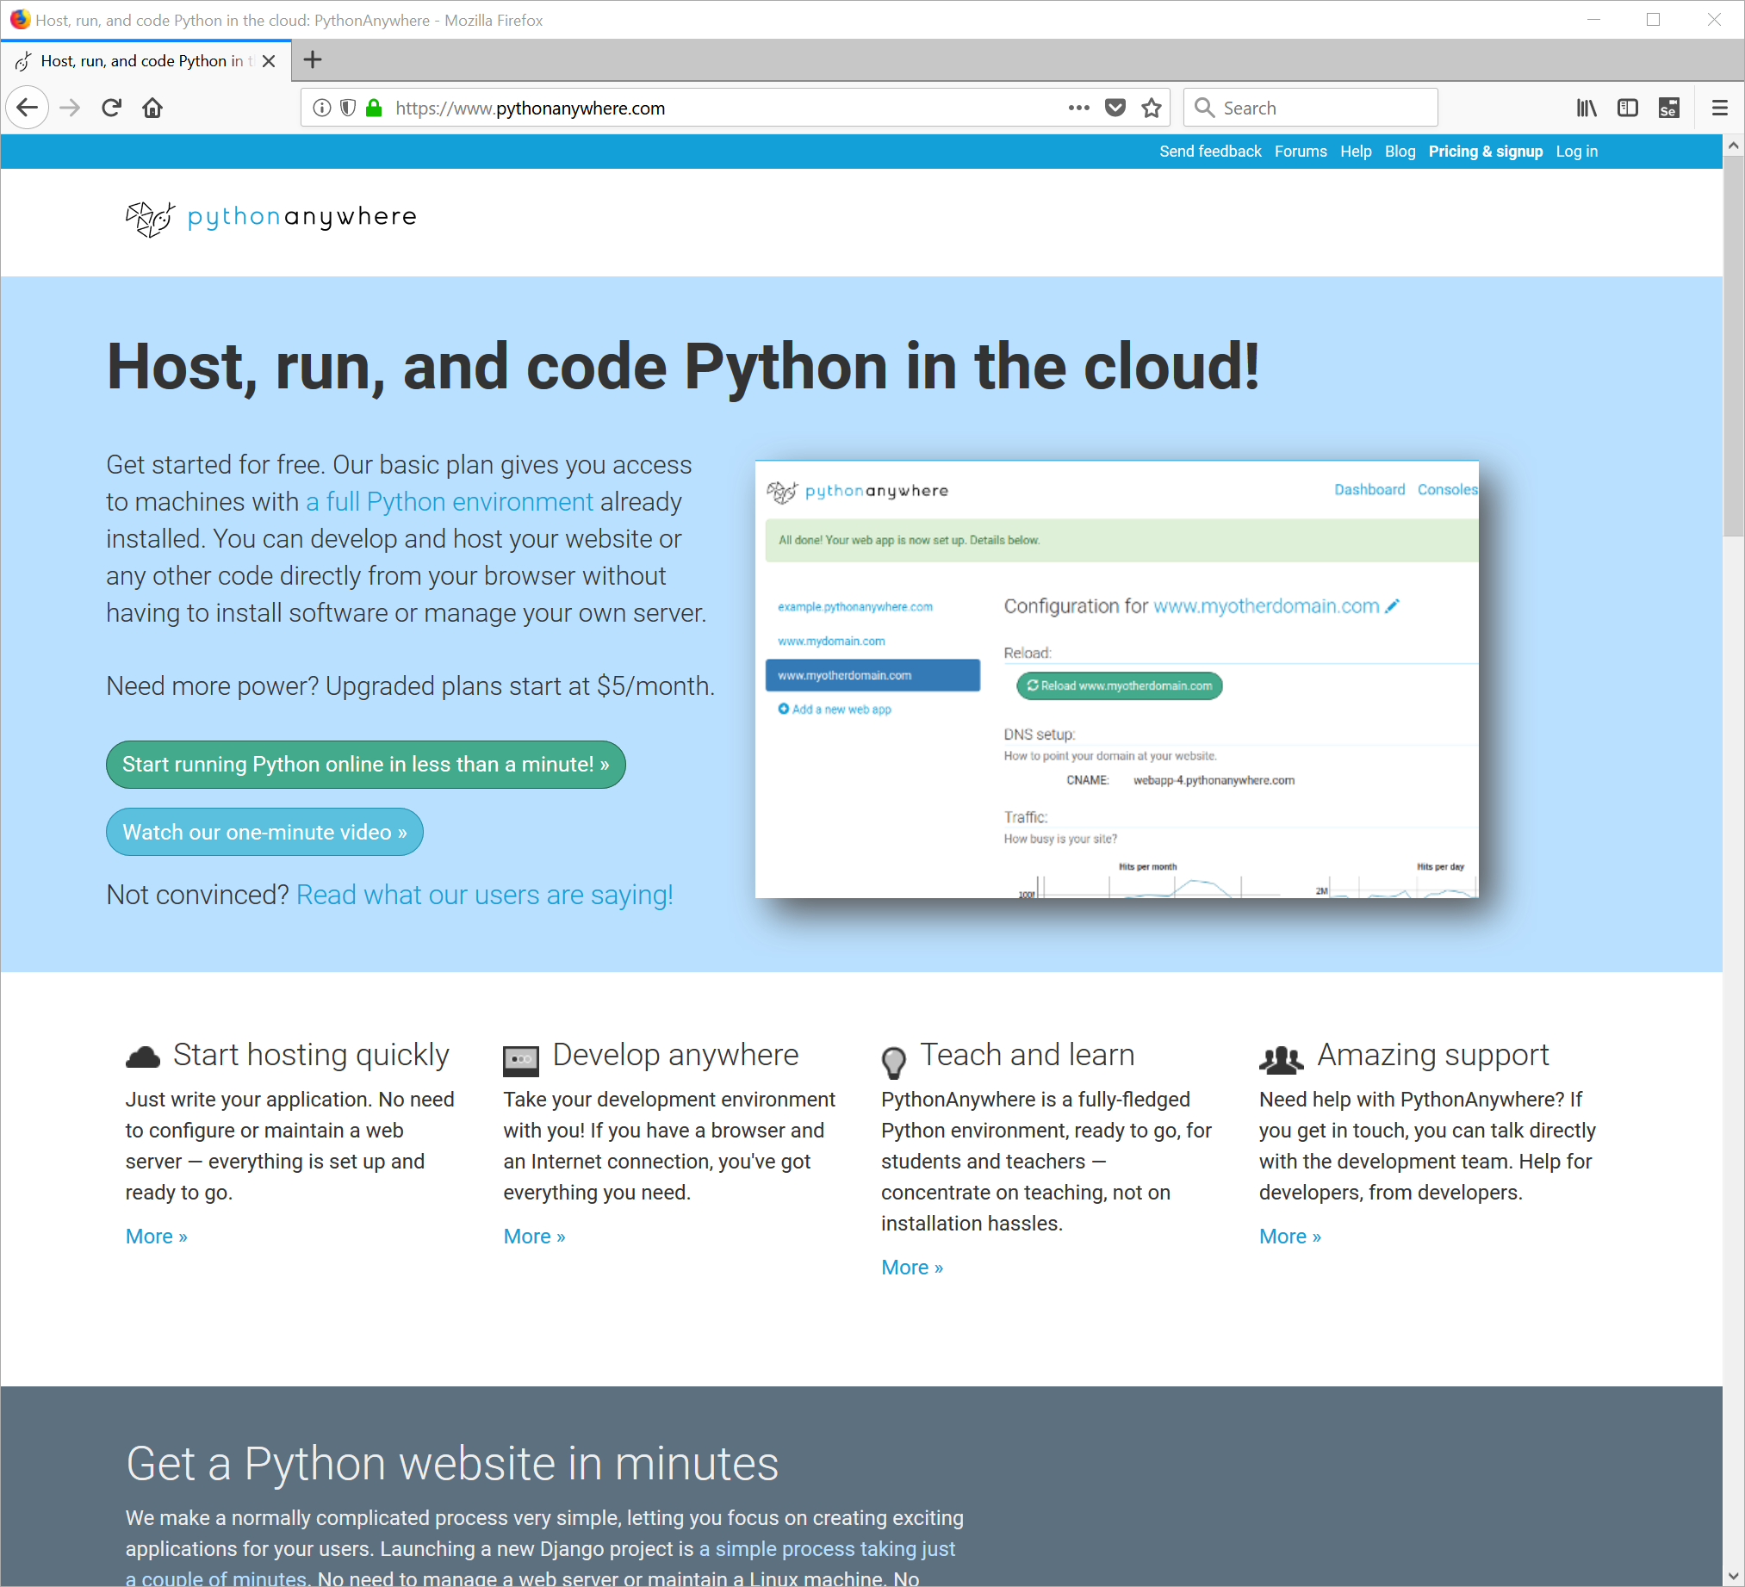

Mouse-Click on the button labeled (Start running Python online in less than a minute)

The following window should appear:

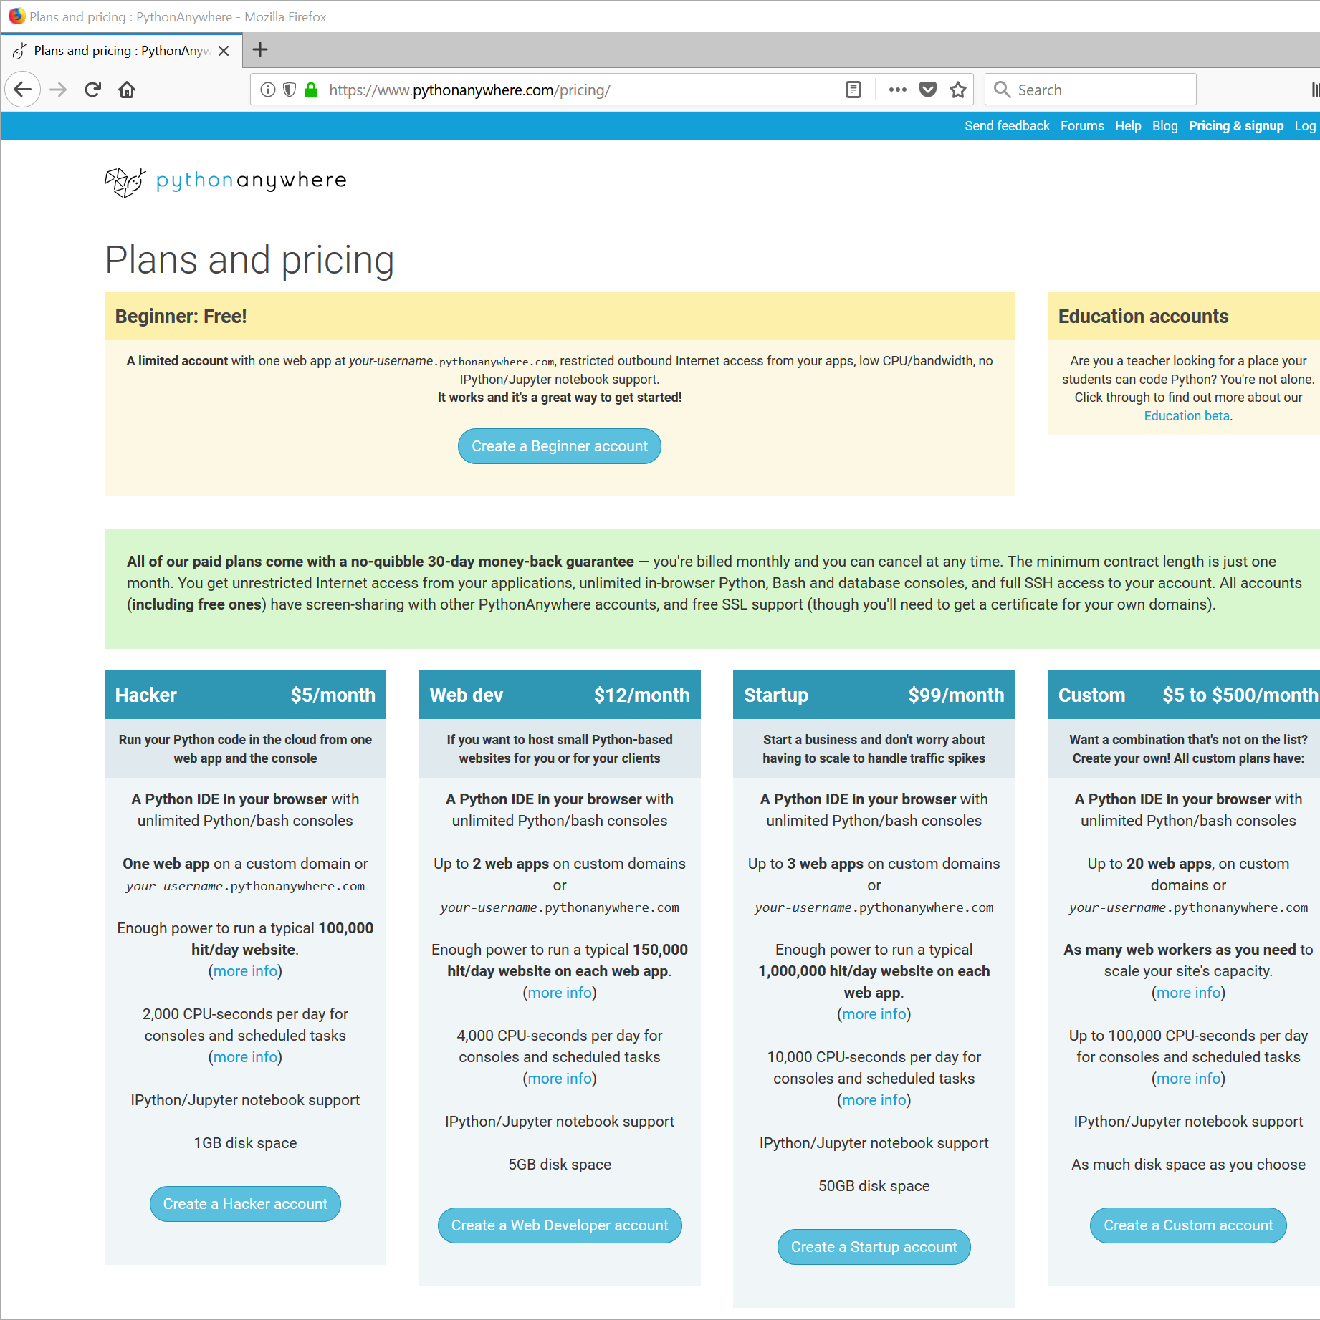

Mouse-Click the button toward the upper middle, labeled (Create a Beginner account)

The following window should appear:

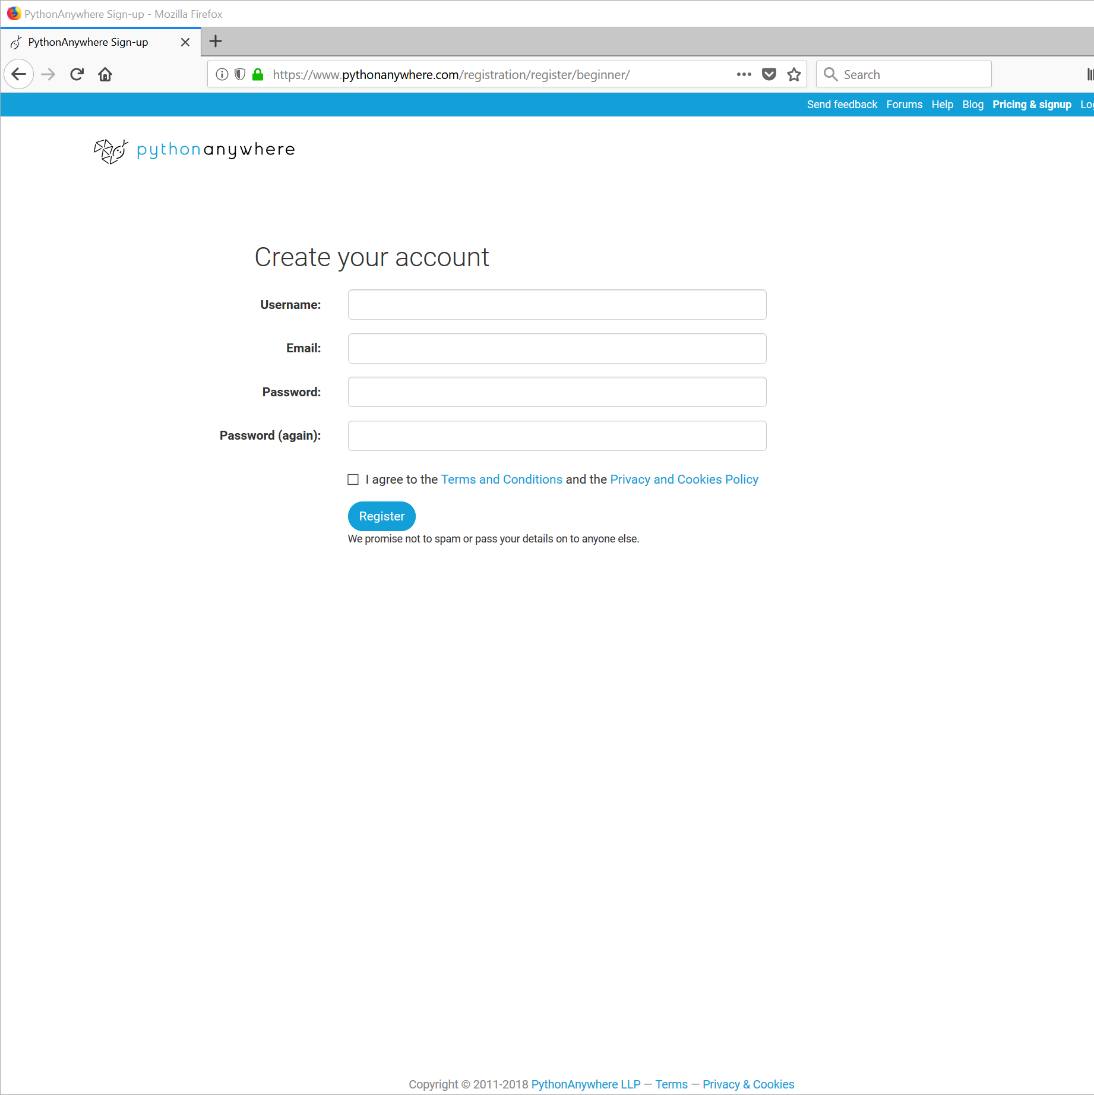

Complete the account entry fields. Please use a password that you can remember and an email address that you will be able to access.

Sample:

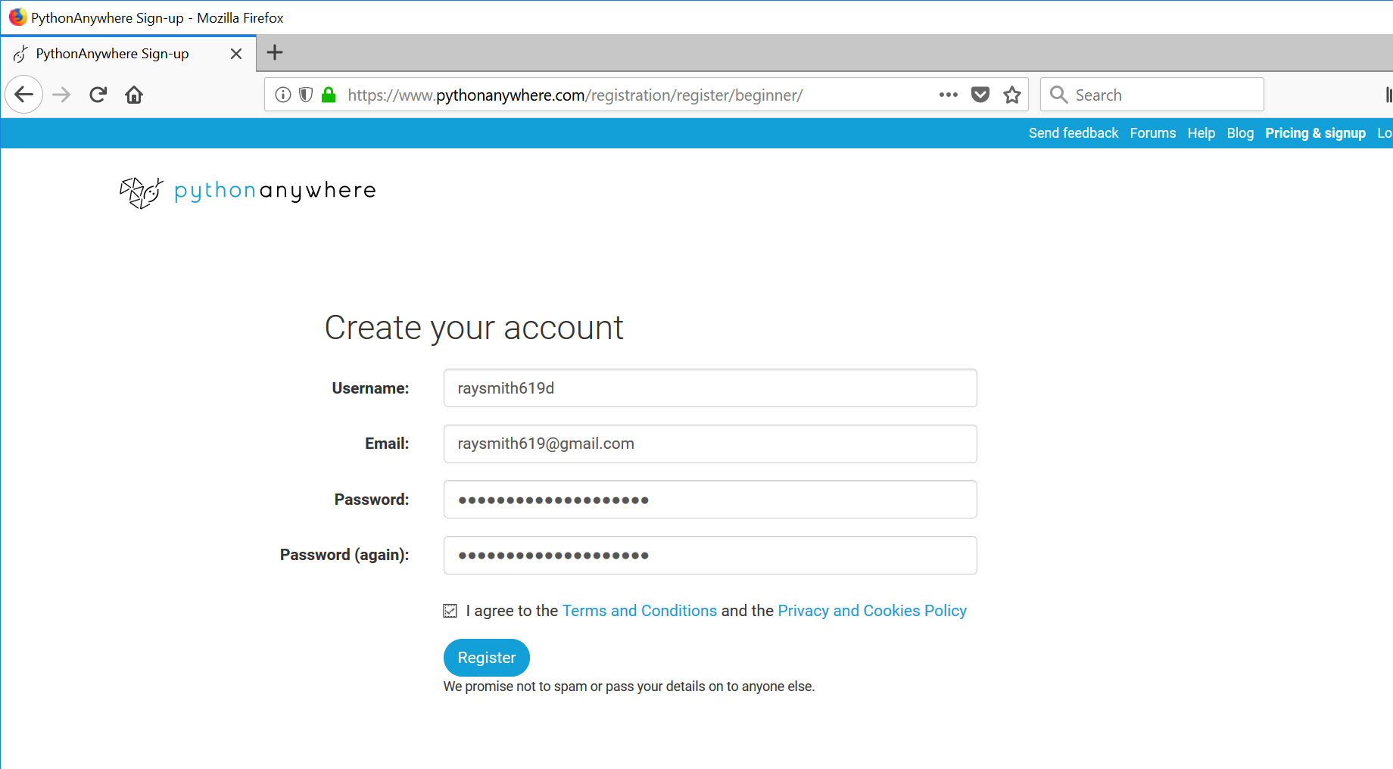

Mouse-Click the button toward the bottom labeled (Register)

The following “Welcome …” dialog box should appear:

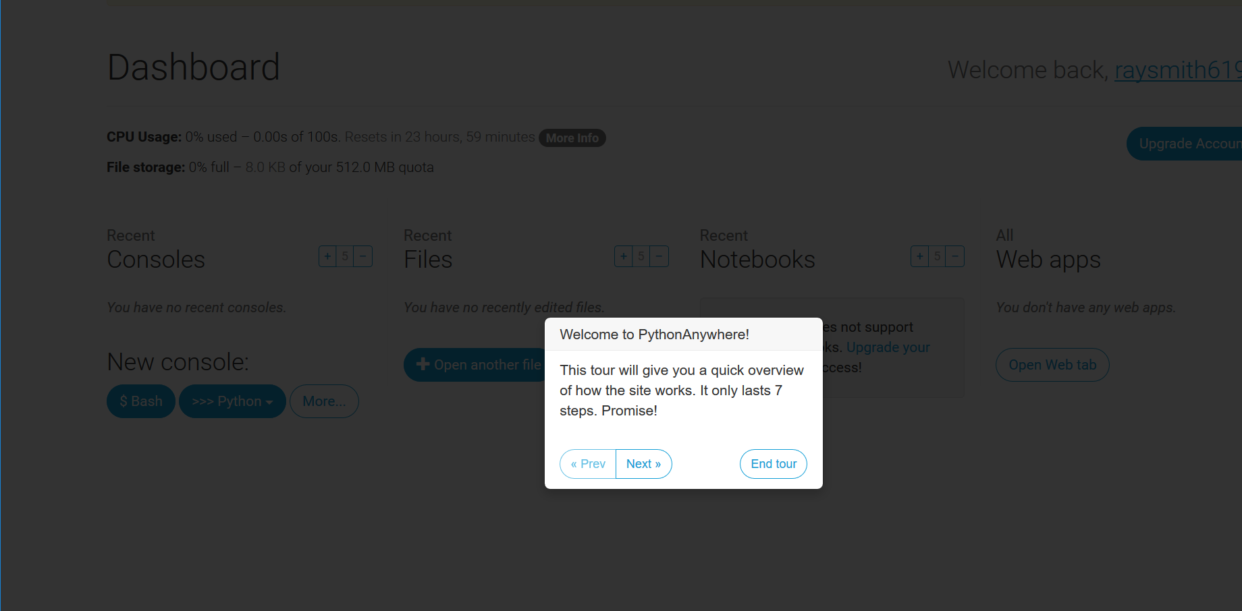

NOTE: You should receive a notification email at your email address supplied similar to the figure below:

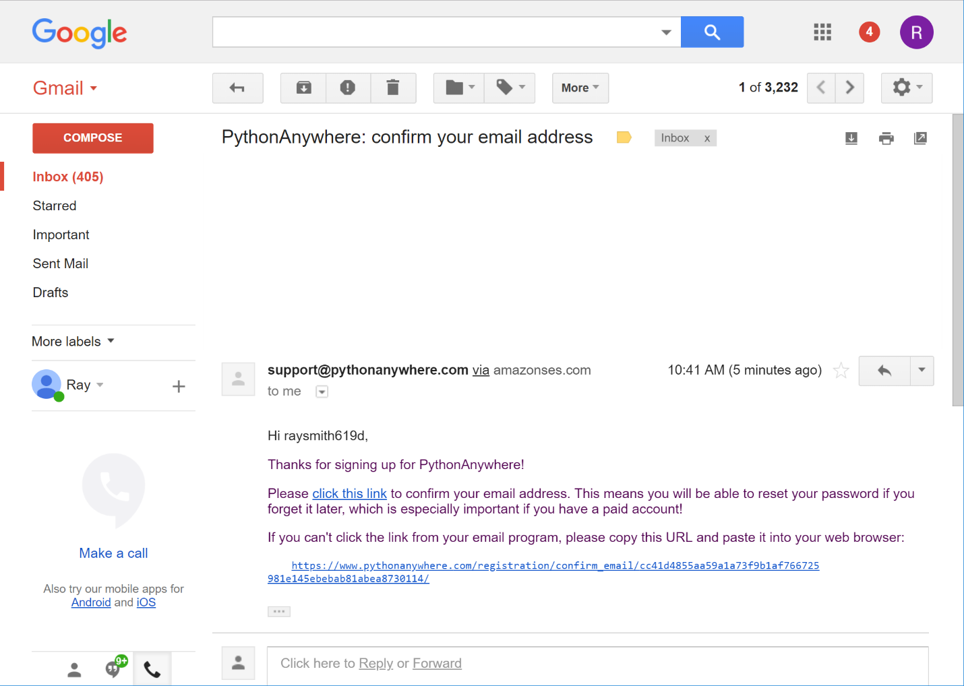

When you receive the email, confirm your email address as requested.

Skip through the tour.

You should end up with the basic PythonAnywhere Dashboard presented in the figure below:

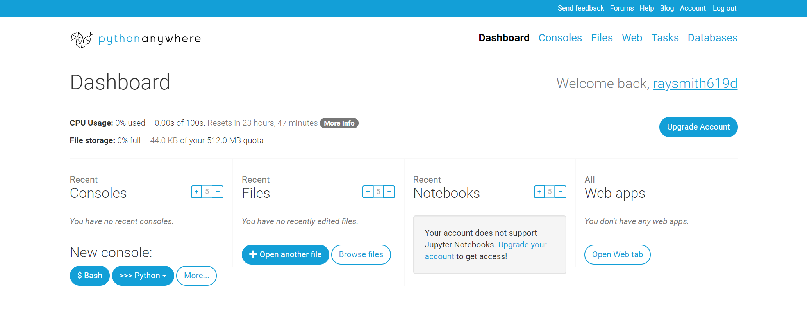

To obtain an interactive Python shell, select the (>>> Python) button as shown in the figure below:

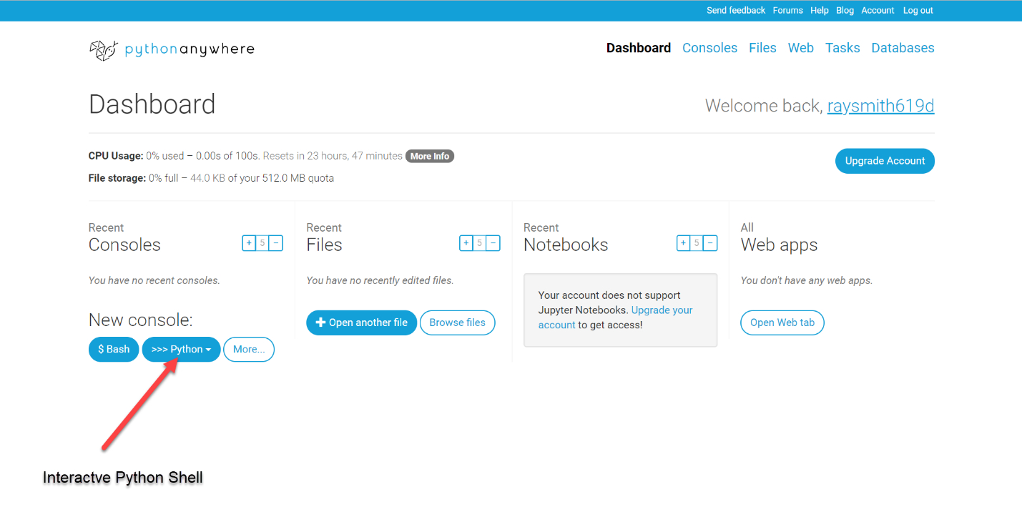

Upon clicking (>>> Python) button, the Version will be requested as shown in the figure below. We will use 3.6.

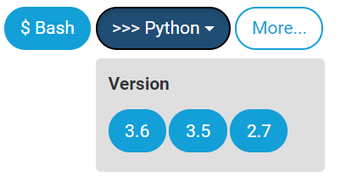

Mouse-click the button labeled (**3.6**)

After a few moments activity a “Python3.6 console” window will appear as in the figure below:

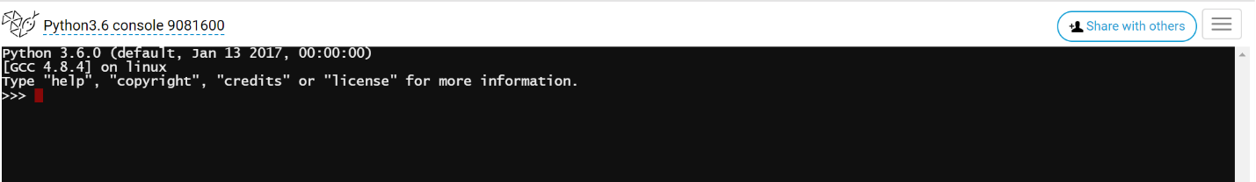

Creating files (for longer programs) in PythonAnywhere:

Start in the PythonAnywhere Dashboard window and select the Files section:

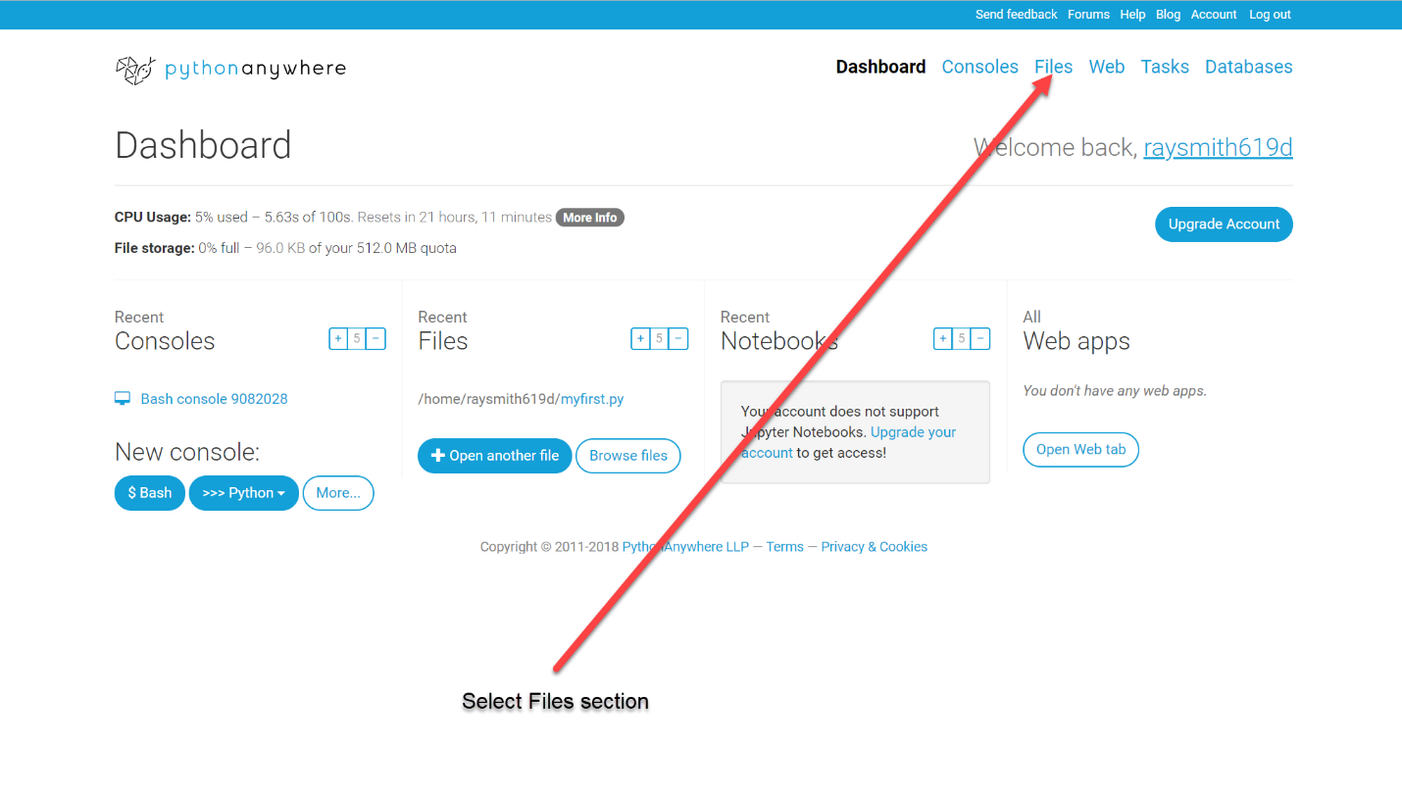

The Files window will appear as below:

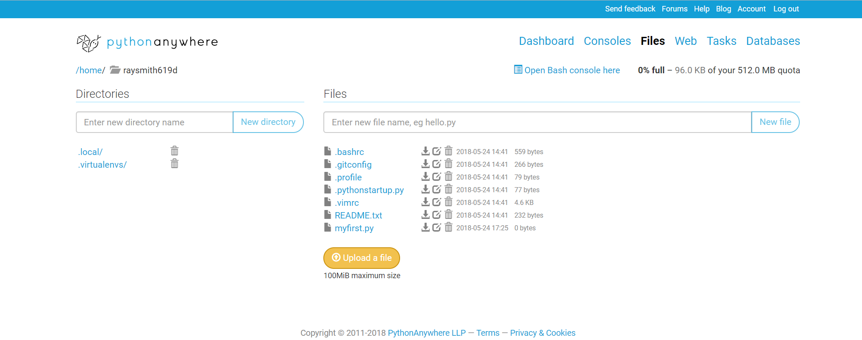

Create a file:

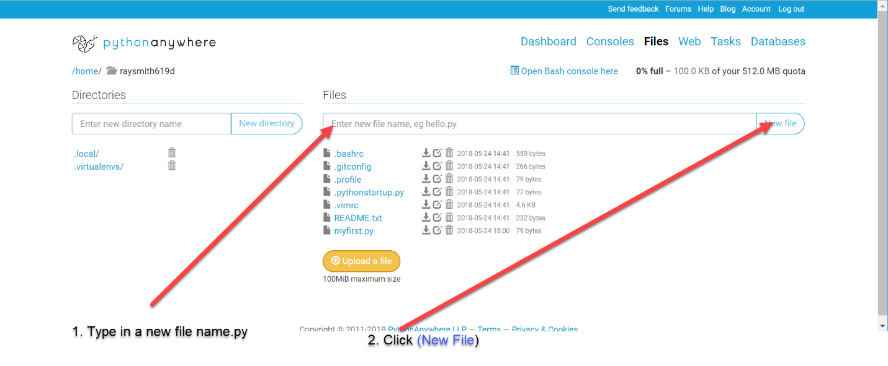

An edit window for this file will appear as below:

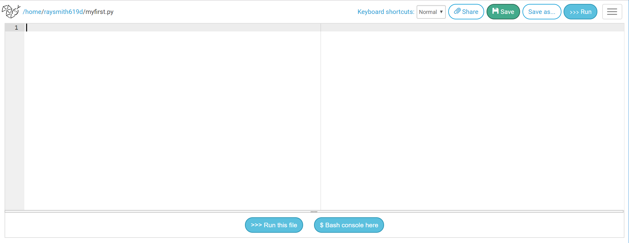

You can enter python code on the left and run this code by clicking the (Run this file) at the bottom.

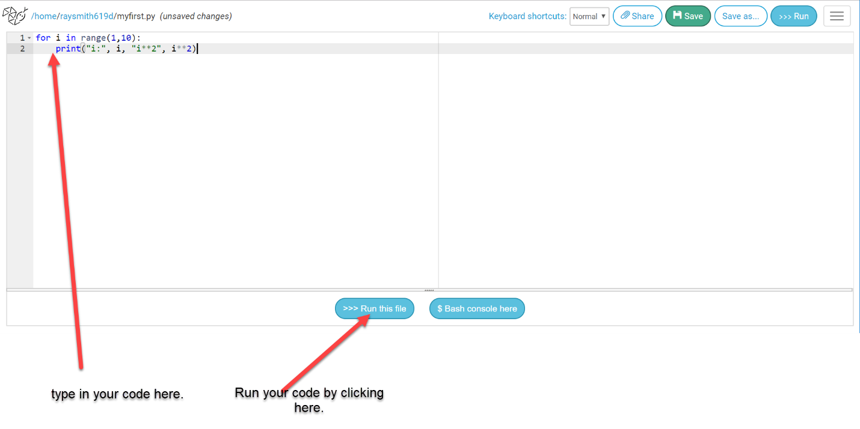

After clicking (Run this file) we see below:

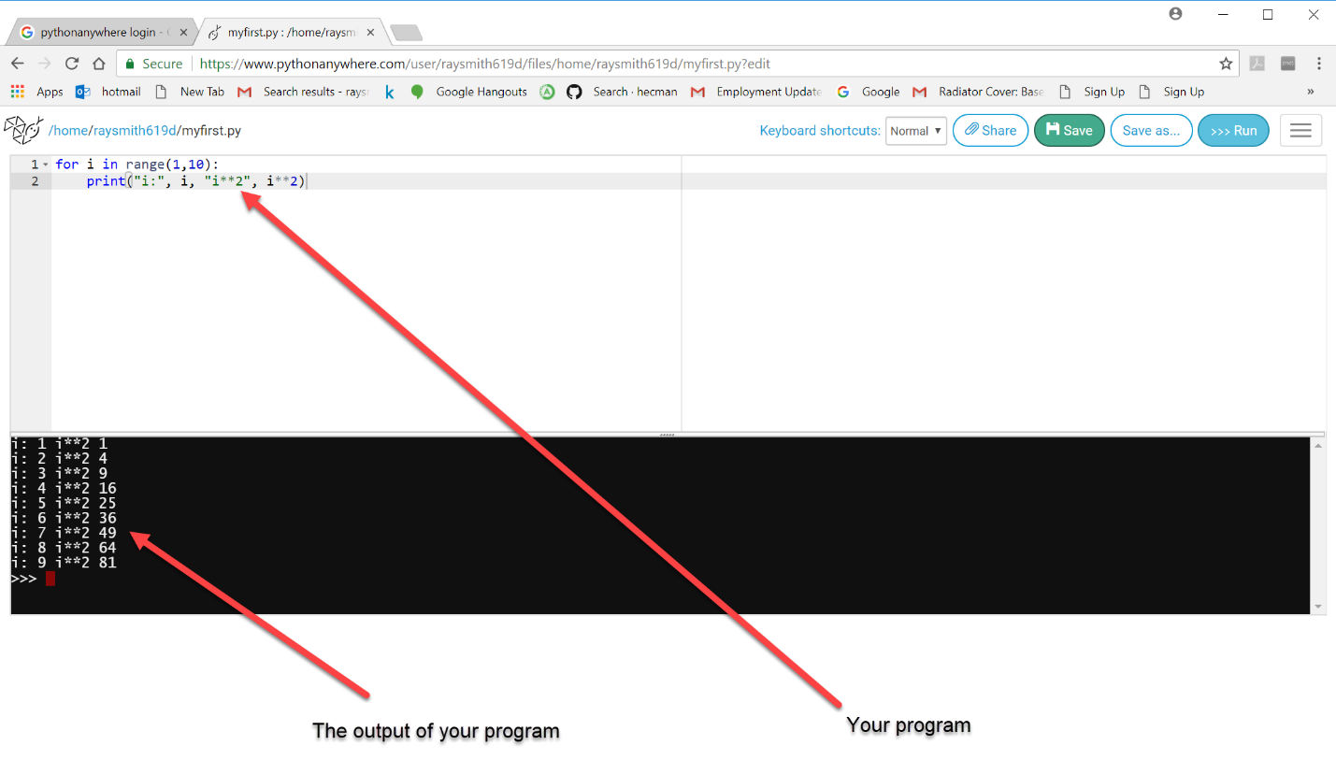

Coming back to a program, after leaving and going to the PythonAnywhere Dashboard:

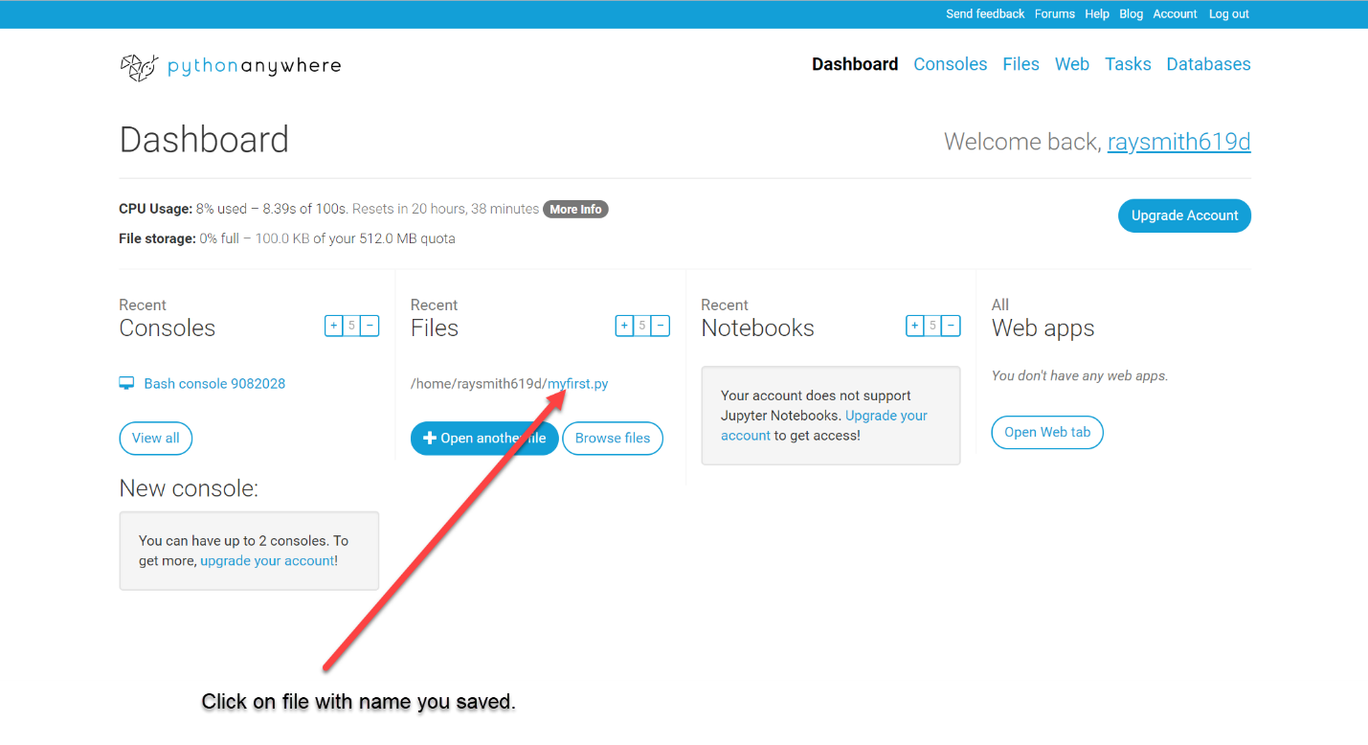

Program file is displayed, plus possibly remembered output, ready for edit and / or running again:

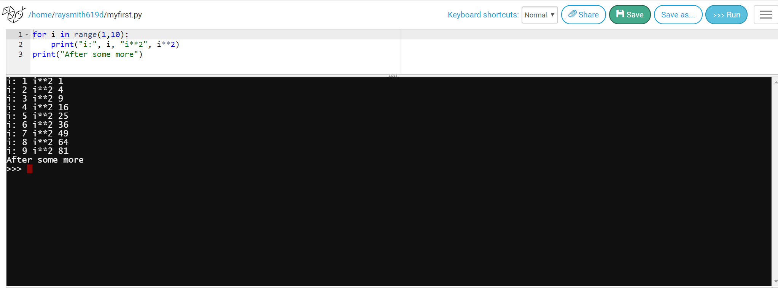

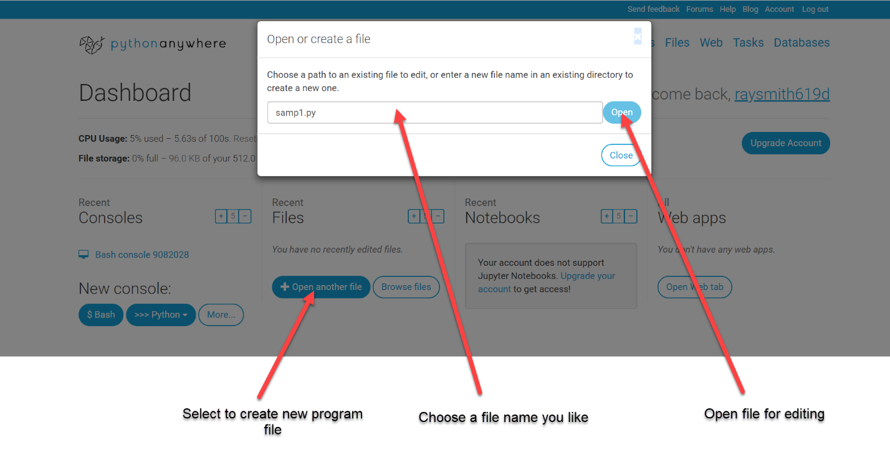

Obtaining Bash Shell (for tools, etc.):

To run a Bash Shell, from the Dashboard window, mouse-click the New console button labeled ($ Bash) as in the figure below:

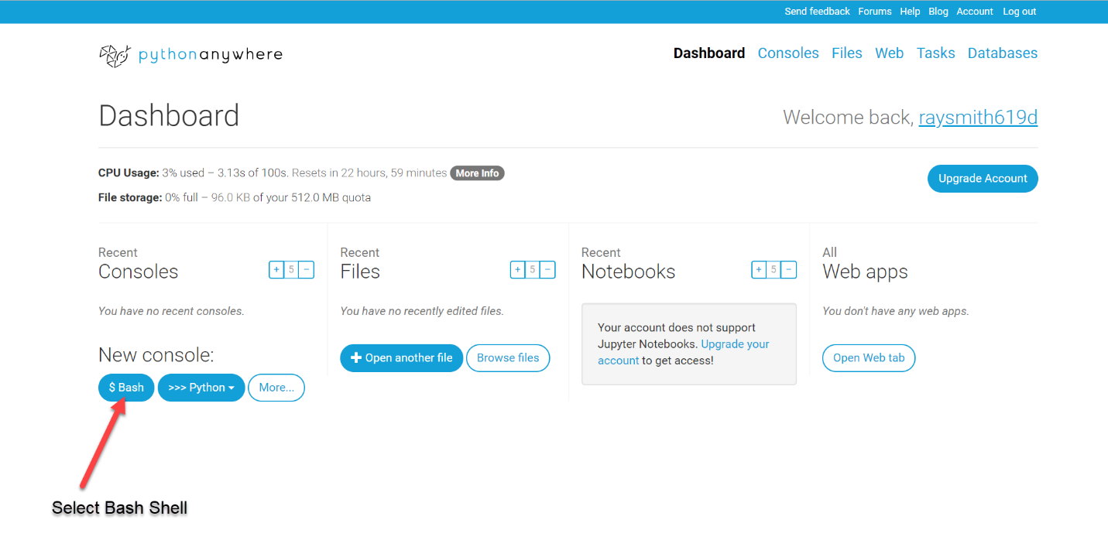

After a few moments, a window with the Bash console will appear as shown in the figure below:

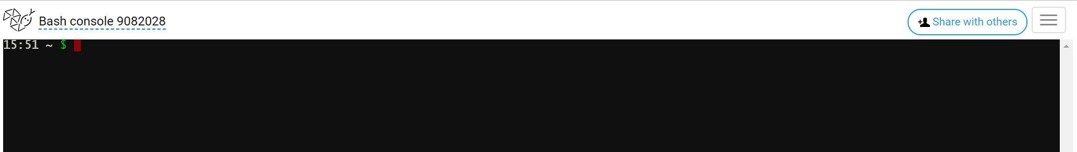

**Reconnecting to PythonAnywhere Account**

To reconnect to your PythonAnywhere account:

Search / Log in – PythonAnywhere:

[Log in - PythonAnywhere](https://www.pythonanywhere.com/login/?next=/)

<https://www.pythonanywhere.com/login/?next=/>

The following window should appear (Possibly already filled out by your browser):

